|  |  |  |  |  |  |
| --- | --- | --- | --- | --- | --- |
|  |  |  |  |  | logo1.png |

|  |  |  |  |
| --- | --- | --- | --- |
| Course Name | | Zoho Books | |
| College Name | | Mangayarkarasi College of Arts and Science for Women Paravai, Madurai - 625002 | |
| College Code | | MKU251 | |
| Skill Offering Id | |  | |
| Project Title | | Preparation and Maintenance of ZOHO Books for fresh bites catering | |
| Project Submitted To | | Madurai Kamaraj University ( Naan Mudhalvan Scheme(TNSDC)) | |
| Year | | 2023 | |
| Department | | B.COM | |
| Semester | | 5 | |
| Group Number | | 24 | |
| Total Members of the Group | | 4 | |
| Group Members Details | | | |
| Name of the Member | University Register. No | | Student NM ID |
| M.Sri Dhanyadevi | C1C15904 | | 62EC9FAF4446B579ECB41D962F029EB3 |
| K.Krishnaveni | C1C15874 | | 27F9F41A11C4A098AE547CA4ED495BEF |
| M.Meena | C1C15878 | | F9A3AE7F088EB3985E9414C40FAACED3 |
| G.Pavithra | C1C15888 | | A816349D0FD703C97A1438C495631B2B |
|  |  | |  |
| Under the Guidance | | Mrs.C.M.Priyanka | |
| SPOC | | Ms.P.UMADEVI | |

**Analysing Housing Prices in Metropolitan areas in India**

1. **Introduction.**

***1.1 Overview***

**Fresh Bites Catering, a catering service, utilizes Zoho Books to manage their sales, track inventory,**

**and handle invoicing. They can generate professional invoices for clients and track expenses related**

**to ingredients and supplies. Zoho Books helps them maintain accurate financial records and streamline**

**their catering operations.**

***1.2 Purpose***

Fresh Bite Catering cater for schools, colleges and universities. We serve a wide selection of food and beverages, whilst keeping in mind the nutritional needs of students by offering a range of healthy meal plans. But we don't just serve any food – we also prioritize the nutritional needs of students.

1. **Problem Definition and Design Thinking**
   1. 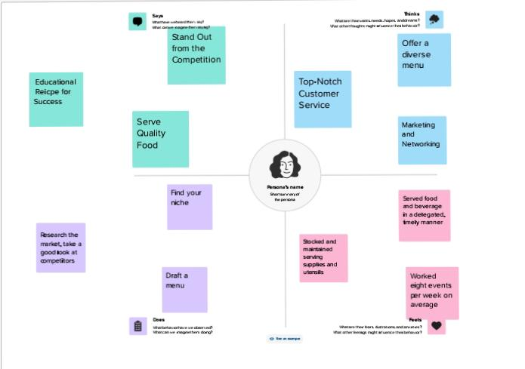Empathy Map

**2.2 Ideation and Brainstroming Map**

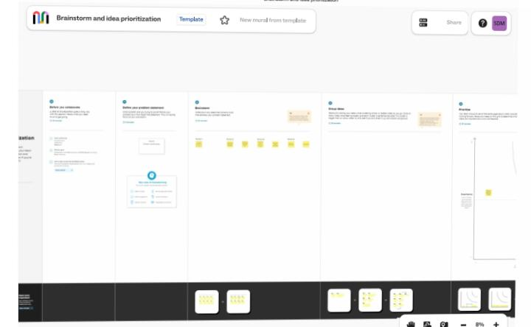

**Milestone 1 Set up your account:**

**Milestone 1 Setup your ac**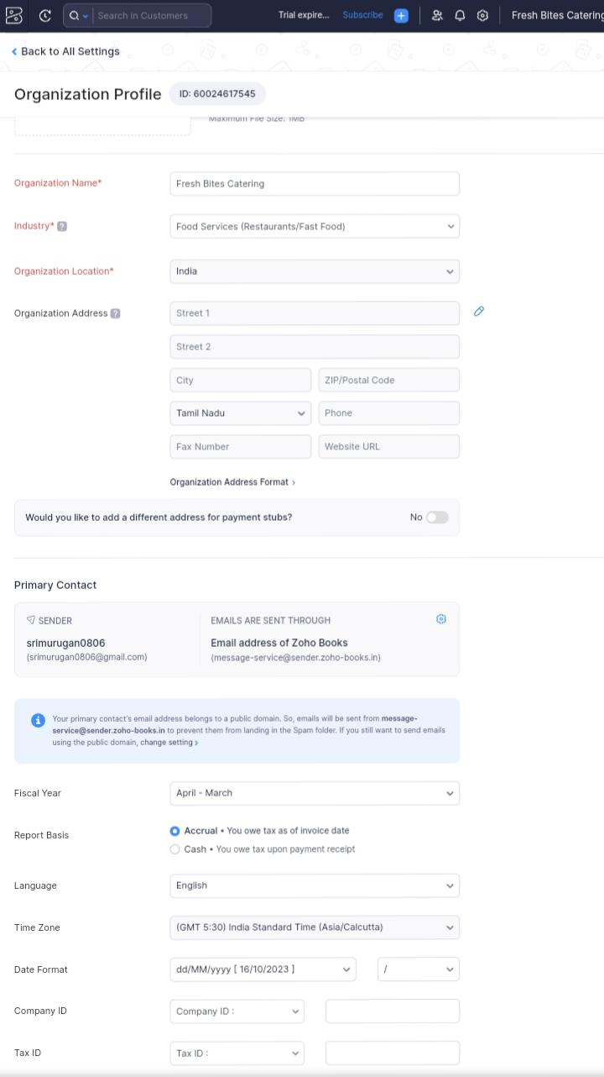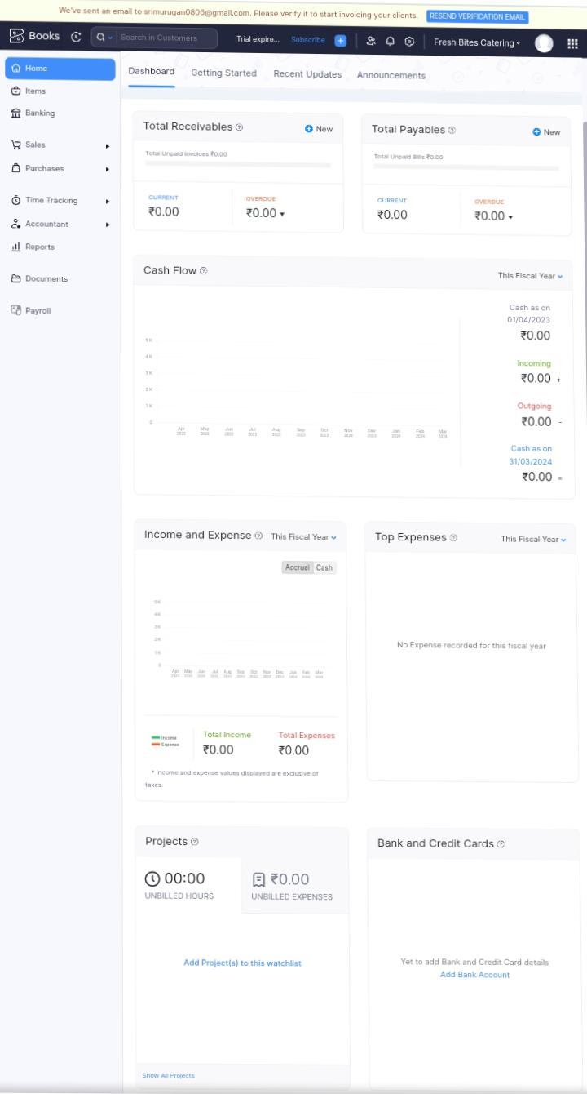

**Milestone 2 products/items:**

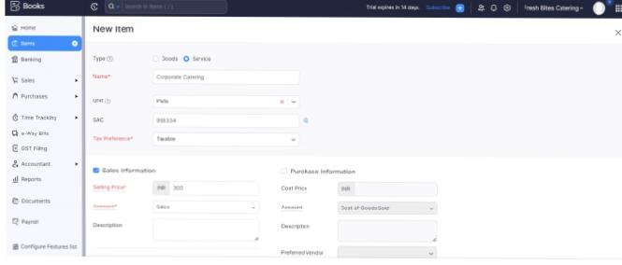

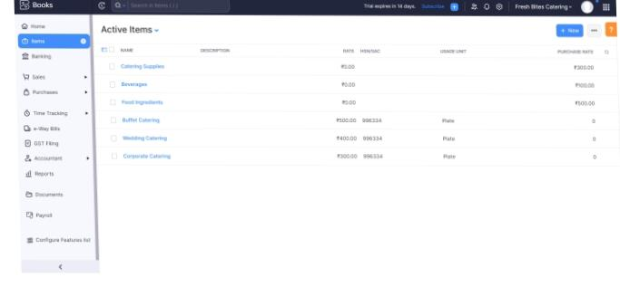

**Milestone 3 vendors:**

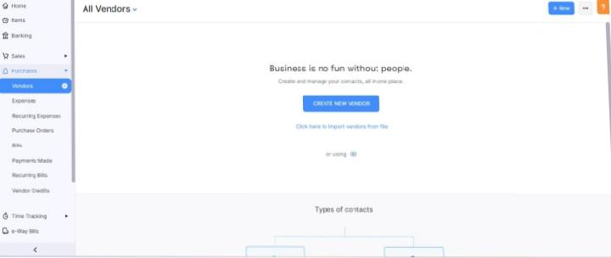

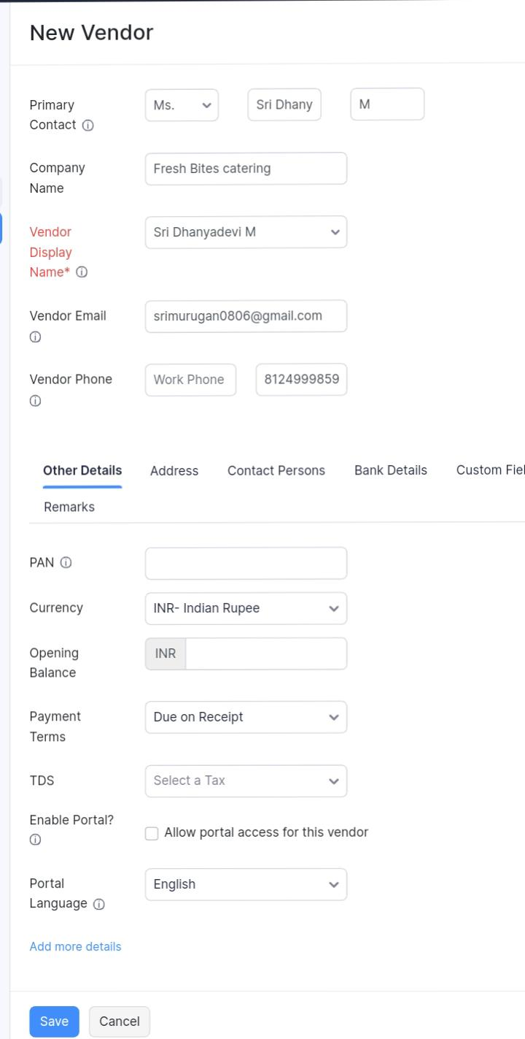

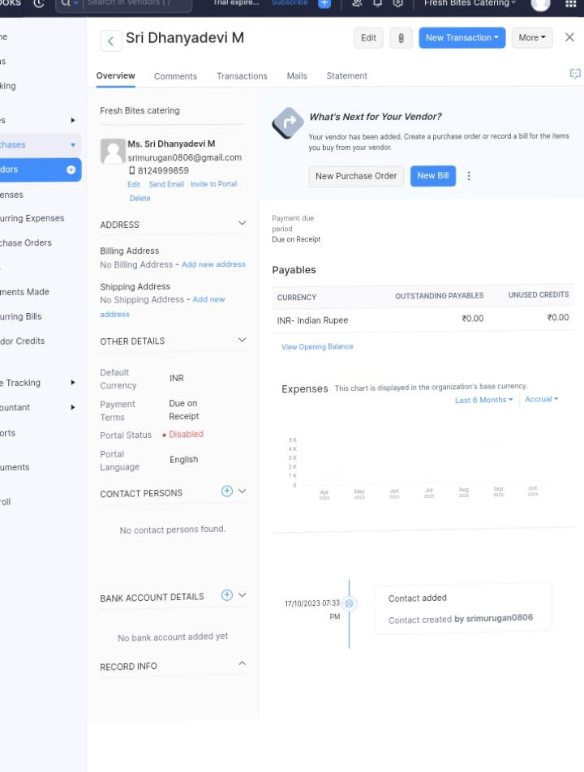

**Milestone 4 Purchase:**

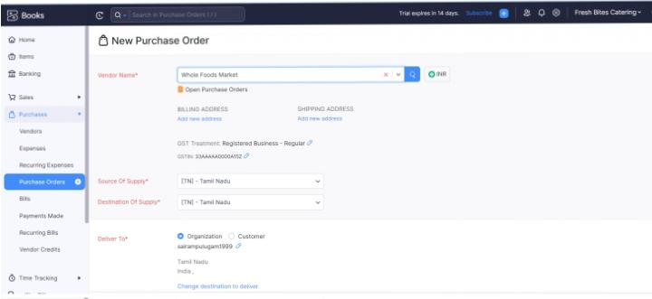

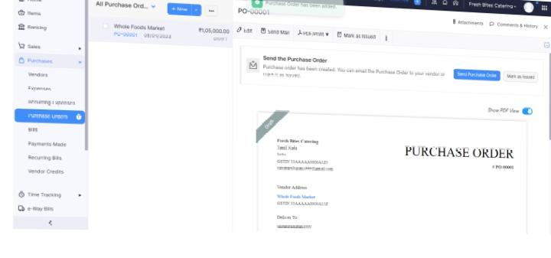

**Milestone 5 Customers:**

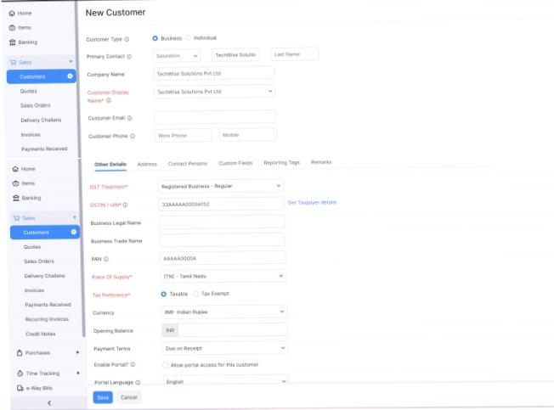

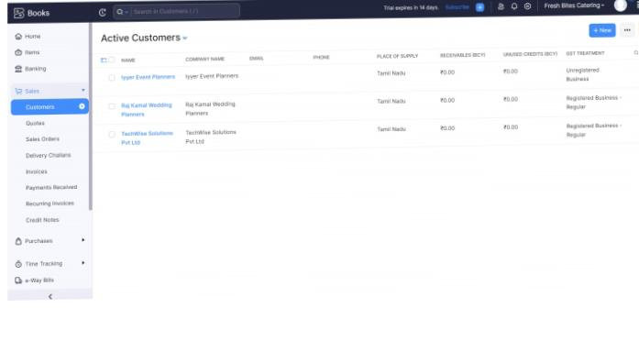

**Milestone 6 Sales:**

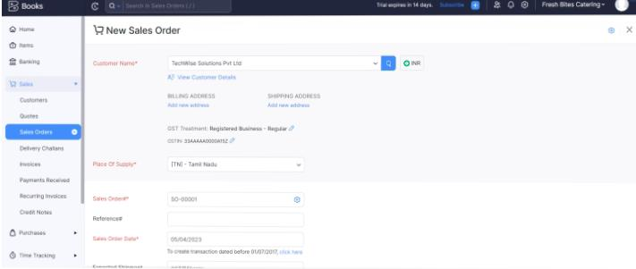

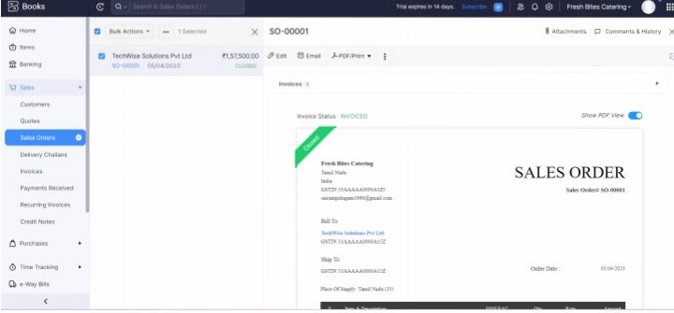

**Milestone 7 Bank account:**

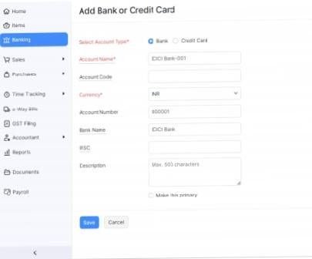

**Milestone 8 Accounts and ledger:**

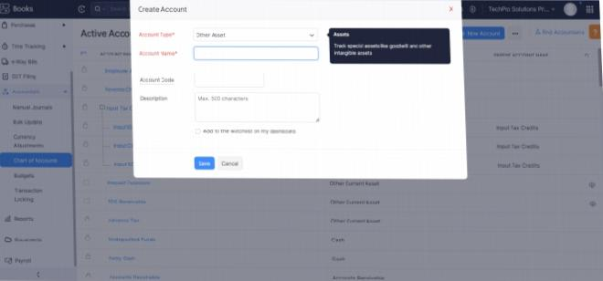

**Milestone 9 Journal entries:**

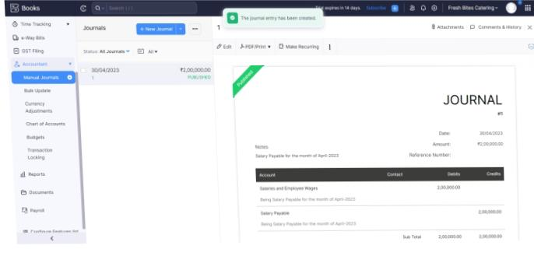

**Milestone 10 Expenses and bill:**

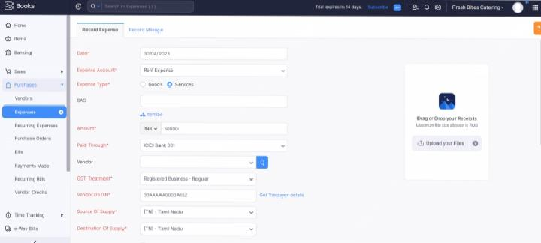

**Milestone 11 Bank entries:**

**For vendor payment**

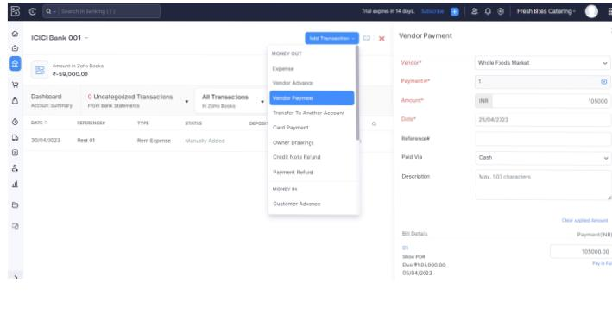

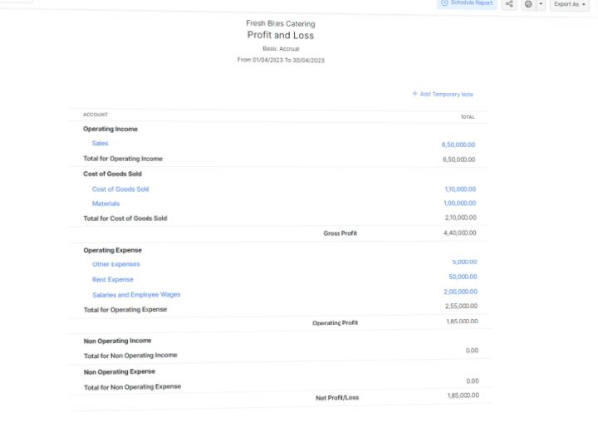

**Milestone 12 Financial reports:**

**Purposes:**

Fresh Bite Catering cater for schools, colleges and universities. We serve a wide selection of food and beverages, whilst keeping in mind the nutritional needs of students by offering a range of healthy meal plans. But we don't just serve any food – we also prioritize the nutritional needs of students.

**Future scope:**

The scope of the catering industry is extensive, ranging from weddings and social gatherings to corporate events and festivals. To establish a catering business, entrepreneurs need to fulfill essential registrations, including an FSSAI license, GST registration, and local permits

**Conclusion:**

* + - * Catering businesses offer off-site service and specialize in providing food and beverage service for events, while restaurants offer an on-site dining experience. Both businesses require different equipment, staffing, and marketing strategies, and they operate on different schedule